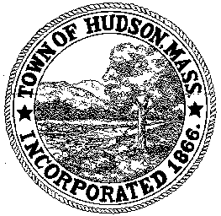

CONSERVATION COMMISSION
78 Main Street, Hudson, MA 01749
(978) 562-2020

Paul Byrne, Chairman W. Minot Wood, Vice Chairman David Esteves, Member

Terrence Joyce, Member Leif Longtine, Member Joseph Rodrigues, Member Al Tashian, Member

Meeting Agenda
March 1, 2012 7:00 P.M.

- Preliminaries
  - Open Meeting
  - Roll Call

2.0 New Business
2.1 DEP 190-0558
Applicant: Town of Hudson
Location: 201 Manning Street
Update on project

2.2 DEP 190-0549 Request for Amendment to Order of Conditions
Applicant: Town of Hudson DPW
Location: Rolling Lane/Four Bridges Road/Rathburn Road/River Road/Chapin Road and Brigham Street

2.3 Request for Review and Comments
350 Main Street, LLC

2.4 Minutes – February 16, 2012

3.0 Old Business

4.0 Correspondence

5.0 Adjournment

Next Meeting: March l 5, 2012

